Biomedical Sensor

Pad

AD8232 Doctor

Heart Attack Monitor

Sensor Cable Send Feedback

Arduino

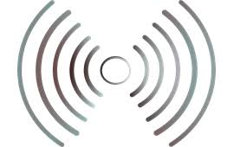

Mobile App

(Process the Data). Send Notification SMS

Start

Initial Sensors

Collect and Process

Data

No Bluetooth

Connected

Yes

Send Data

To

Mobile

End

Start

Analyze data

No

Anomaly

Detected

yes

Send SMS

Notification

End